Taxonomy of Positions in the Free Will Debates 
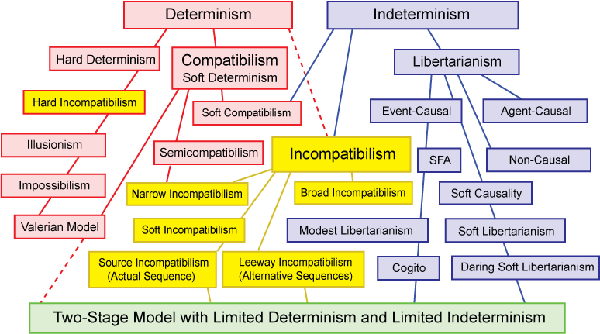
Determinism is the position that every event is caused, in a chain of events with one possible future.

"Hard" and "soft" determinism are terms invented by William James who lamented the fact that some determinists were co-opting the term freedom for themselves. He called them "soft" determinists, because, abhoring harsh words like fatality, necessity, and even predetermination, they say determinism’s “real name is freedom; for freedom is only necessity understood, and bondage to the highest is identical with true freedom.”

"Hard" determinists deny the existence of free will. "Soft" determinists co-opt the term “free will.”

Compatibilism is the most common name used today for James's category of soft determinism. For compatibilists, free will is compatible with determinism (would be, if determinism were true, some say).

Semicompatibilists are agnostic about free will and determinism, but claim that moral responsibility is compatible with determinism, in any case. Narrow incompatibilism is a similar concept.

Hard incompatibilists think both free will and moral responsibility are not compatible with determinism.

Illusionists are hard incompatibilists, who say free will is an illusion and usually deny moral responsibility. Some say we should preserve moral responsibility by maintaining the illusion.
Impossibilists are also hard incompatibilists. They say moral responsibility is impossible.
Incompatibilism is the idea that free will and determinism are incompatible. Incompatibilists include both hard determinists and libertarians. This confuses the debate by analytic language philosophers - who are normally committed to clear and unambiguous concepts - and adds difficulties for students of philosophy.
Soft incompatibilists says that free will is incompatible with pre-determinism, and that pre-determinism is not true. It is preferable to the loose usage of the term "incompatibilist" to describe a libertarian, since "incompatibilist" is ambiguous and also used for determinists (hard incompatibilists).

Source and Leeway incompatibilists locate indeterminism in the Actual Sequence or Alternative Sequences. The first in each pair breaks the causal chain, the last provide alternative possibilities.

Indeterminism is the position that there are random (chance) events in a world with many possible futures.

Libertarians believe that the indeterminism makes free will possible. Note that there many philosophers who admit indeterminism may be true but that it does not provide free will ("hard" indeterminists?). See the standard argument against free will. If our actions are determined, we are not free. If they are random, we are not responsible for them. So indeterminism is not enough. We also need “adequate determinism” in a second stage.

Agent-causal indeterminists are libertarians who think that agents originate causes for their actions. These causes are not events. So actions do not depend on any prior causes. Some call this “metaphysical” freedom.

Non-causal indeterminists simply deny any causes whatsoever for libertarian free will.

Event-causal indeterminists generally accept the view that random events (most likely quantum mechanical events) occur in the world. Whether in the physical world, in the biological world (where they are a key driver of genetic mutations), or in the mind, randomness and uncaused events are real. They introduce the possibility of accidents, novelty, and both biological and human creativity.

Soft Causality is the idea that most events are adequately determined by normal causes, but that some events are not precisely predictable from prior events, because there are occasional quantum events that start new causal chains with unpredictable futures. These events are said to be causa sui.

Soft Libertarians accept some indeterminism in the Actual Sequence. They are source incompatibilists.
Two-Stage Models – combine limited Determinism and Indeterminism
Two-stage models for free will have been discussed by many thinkers including William James, Henri Poincaré, Arthur Holly Compton, Karl Popper, Daniel Dennett (Valerian), Henry Margenau, Robert Kane, John Martin Fischer, Alfred Mele (Modest Libertarian), Stephen Kosslyn, Bob Doyle (Cogito Model), and Martin Heisenberg.
Two-stage models include both “adequate determinism” (which denies pre-determinism) and indeterminism limited to generating alternative possibilities for action. It is pre-determinism that is incompatible with free will.
Thoughts come to us freely. Actions go from us willfully. First chance, then choice. First “free,” then “will.”
Sources: (blue links are active in the original document (http://www.informationphilosopher.com/freedom/taxonomy.html)
www.informationphilosopher.com/freedom/history
www.informationphilosopher.com/freedom/problem
www.informationphilosopher.com/freedom/two-stage_models.html
www.informationphilosopher.com/freedom/standard_argument.html
Contact: bobdoyle@informationphilosopher.com

